Lab Assignment 4

Functions

1. Write a program to define a function sum ( ) that takes two integer arguments and return the result to the calling function.

#include<stdio.h>

     int sum(int x,int y)   
   {   
        int z;   
        z=x+y;  
        return z;   
 }

int main()   
 {   
        int a,b,f;  
        printf("Enter Two Numbers : ");   
        scanf("%d%d",&a,&b);   
       f= sum(a,b);

printf("Sum of Two Number is : %d",f);  
 return 0;  
 }

1. Write a function swap ( ) that takes two arguments and swaps the values. Using a function, return the second largest among three numbers.

#include<stdio.h>

void swap(int *x,int *y)

{

int z;

z=*x;

*x=*y;

*y=z;

}

int main()

{

int a,b;

printf("Enter Two Numbers : ");

scanf("%d%d",&a,&b);

swap(&a,&b);

printf("The Two Numbers after swapping is : %d and %d",a,b);

return 0;

}

#include<stdio.h>

int second(int x,int y,int z)

{

if(((x>y)&&(x<z) )||((x<y)&&(x>z) ))

return x;

else if(((y>x)&&(y<z) )||((y<x)&&(y>z) ))

return y;

else

return z;

}

int main()

{

int a,b,c,f;

printf("Enter Three Numbers : ");

scanf("%d%d%d",&a,&b,&c);

f=second(a,b,c);

printf("The second largest number among three is %d",f);

return 0;

}

1. Write a program to find the largest digit in a number. Use a function that takes an integer number as an argument.

#include<stdio.h>

int digit(int n)

{

int d=0,a;

while(n!=0)

{

a=n%10;

if(d<a)

d=a;

n=(n-a)/10;

}

return d;

}

int main()

{

int a,f;

printf("Enter a Number : ");

scanf("%d",&a);

f=digit(a);

printf("The largest digit is %d",f);

return 0;

}

1. Write a program to print the sum of 1+2+3+…+n. Use a function with limit as the argument.

#include<stdio.h>

int sequence(int n)

{

int c=0;

for(int i=1;i<=n;i++)

c=c+i;

return c;

}

int main()

{

int a,f;

printf("Enter the limit : ");

scanf("%d",&a);

f=sequence(a);

printf("The sum of sequence is %d",f);

return 0;

}

1. Write a program that accepts three numbers and using a function returns the largest among the numbers.

#include<stdio.h>

int largest(int x,int y,int z)

{

if((x>y)&&(x>z))

return x;

else if((y>x)&&(y>z) )

return y;

else

return z;

}

int main()

{

int a,b,c,f;

printf("Enter Three Numbers : ");

scanf("%d%d%d",&a,&b,&c);

f=largest(a,b,c);

printf("The largest number among three is %d",f);

return 0;

}

1. Write a program that reads a number and finds the factorial using a function that takes an integer number.

#include<stdio.h>

int fact(int n)

{

int c=1;

for(int i=1;i<=n;i++)

c=c*i;

return c;

}

int main()

{

int a,f;

printf("Enter a number : ");

scanf("%d",&a);

f=fact(a);

printf("The factorial of %d is %d",a,f);

return 0;

}

1. Write a menu driven program with the following options:-
   * Add
   * Difference
   * Product
   * Division

Use functions for each of the menu with proper arguments, return type and function name.

#include<stdio.h>

int add(int m,int n)

{

int c= m+n;

return c;

}

int minus(int n,int m)

{

int c= m-n;

return c;

}

int prod(int n,int m)

{

int c= m*n;

return c;

}

int div(int n,int m)

{

int c= m/n;

return c;

}

int main()

{

int a,c,f;

int b;

printf("Enter a number : ");

scanf("%d%d",&a,&c);

printf("Enter a operation : 1 for add, 2 for subtract, 3 for multiply and 4 for division ");

scanf("%d",&b);

switch(b)

{

case 1:

f=add(a,c);

break;

case 2:

f=minus(a,c);

break;

case 3:

f=prod(a,c);

break;

case 4:

f=div(a,c);

break;

}

printf("%d %d = %d",a,c,f);

return 0;

}

1. Write a menu driven program with the following menus:-
   * Area of circle
   * Perimeter of circle
   * Area of rectangle
   * Perimeter of a rectangle

Use functions for each of the menu with proper arguments, return type and function name.

#include<stdio.h>

const pi=22/7;

float area1(float m)

{

float c=pi*m*m;

return c;

}

float peri1(float n)

{

float c=2*pi*n;

return c;

}

float area2(float n,float m)

{

float c= n*m;

return c;

}

float peri2(float n,float m)

{

float c= 2*(m+n);

return c;

}

int main()

{

float a,c,f;

int b;

printf("Enter a operation : 1 area of circle, 2 for perimeter of circle, 3 for area of rectangle and 4 for perimeter of rectangle ");

scanf("%d",&b);

if ((b==1)||(b==2))

{

printf("Enter radius of circle ");

scanf("%f",&a);

}

else

{

printf("Enter length and breadth of rectangle ");

scanf("%f%f",&a,&c);

}

switch(b)

{

case 1:

{ f=area1(a);

printf("The area of circle is %1.3f",f);

break;}

case 2:{

f=peri1(a);

printf("The perimeter of circle is %1.3f",f);

break;}

case 3:{

f=area2(a,c);

printf("The area of rectangle is %1.1f",f);

break;}

case 4:

{ f=peri2(a,c);

printf("The perimeter of rectangle is %1.1f",f);

break;}

}

return 0;

}

1. Write a program to find the sum of series 1/1! + 4/2! + 27/3! +… …. Using functions, find the sum of the series.

#include<stdio.h>

#include<math.h>

float fact(float m)

{

float c=1;

for(float i=1;i<=m;i++)

{

c=c*i;

}

return c;

}

float sequence(float n)

{

float d, c=0;

for(float i=1;i<=n;i++)

{

d=pow(i,i);

c=c+d/fact(i);

}

return c;

}

int main()

{

float a,f;

printf("Enter the limit ");

scanf("%f",&a);

f=sequence(a);

printf("%1.3f",f);

return 0;

}

1. Write a function to calculate compound interest given the principal, rate of interest and number of years.

#include<stdio.h>

#include<math.h>

float ci(float p,float t,float r)

{

float c;

c=p*pow((1+(r/100)),t)-p;

return c;

}

int main()

{

float a,b,c,f;

printf("Enter the principal, time and rate of interest ");

scanf("%f%f%f",&a,&b,&c);

f=ci(a,b,c);

printf("The compound interest for rs %1.0f for %1.0f years with rate of %1.0f is %1.3f",a,b,c,f);

return 0;

}

1. Write a function to print the first n terms of the Fibonacci series.

#include<stdio.h>

void fibo(int a)

{

int b=0, c=1,d;

for(int i=1;i<=a;i++)

{

d=b+c;

printf("%d ",b);

b=c;

c=d;

}

}

int main()

{

int a;

printf("Enter the number of terms ");

scanf("%d",&a);

fibo(a);

return 0;

}

1. Write a function to print the non-Fibonacci series until n. For example if n is 10 your program should display 4, 6, 7, 9, 10. Do not use arrays in the program.

#include<stdio.h>

#include<math.h>

void fibo(int a)

{

int b=1, c=2,d;

while(b<a)

{

d=b+c;

b=c;

c=d;

for(int j=b+1;j<c;j++)

{

if(c<a)

printf("%d ",j);

}

}

}

int main()

{

int a;

printf("Enter a limit ");

scanf("%d",&a);

fibo(a);

return 0;

}

1. Print the prime factors of a given number using a function.

#include<stdio.h>

int prime(int i)

{

for (int j=2;j<i;j++)

if(i % j ==0)

{

return 0;

break;

}

}

void factors(int a)

{

for(int i=2;i<=a;i++)

{

int f=0;

if(a%i == 0)

{

f= prime(i);

}

if(f!=0)

printf("%d ",i);

}

}

int main()

{

int a;

printf("Enter a number ");

scanf("%d",&a);

printf("The prime factors of %d are ",a);

factors(a);

return 0;

}

1. Write a C program that does the following, using functions.
   * It asks the user to enter an integer between 100 and 9999.
   * If the entered number is out of range, the program ask the user to enter a valid number.
   * Then the program prints the digits in words of the number on separate lines. Here is an example

Enter an integer between 100 and 9999: 99 Invalid Input

Enter an integer between 100 and 9999: 987 Seven Eight Nine

#include<stdio.h>

void letter(int i)

{

if (i==0)

printf("Zero ");

else if(i==1)

printf("One ");

else if(i==2)

printf("Two ");

else if(i==3)

printf("Three ");

else if(i==4)

printf("Four ");

else if(i==5)

printf("Five ");

else if(i==6)

printf("Six ");

else if(i==7)

printf("Seven ");

else if(i==8)

printf("Eight ");

else

printf("Nine ");

}

int main()

{

int a,d;

printf("Enter a number between 100 and 9999 ");

scanf("%d",&a);

int n=a;

if((a>=100)&&(a<=9999))

{

printf("The number in words are ");

while(n>0)

{

d=n%10;

letter(d);

n=(n-d)/10;

}

}

else

{

printf("Enter number again \n");

main();

}

return 0;

}

1. The following types of chocolates are available in a chocolate shop. Write a menu driven program to display the chocolate type, price and discount. Get the customer’s choice and the number of chocolates required. Assume that each customer can buy only one type of chocolate. Use switch case to calculate the total amount with discount for each customer and display it. Use a function to calculate total amount. Also keep track of how many of each type of chocolate was sold throughout the day and print it using a function.

|  |  |  |  |
| --- | --- | --- | --- |
| Sl.no | Chocolate Type | Price (Rs.) | Discount (%) |
| 1 | White Chocolate | 50 | 10 |
| 2 | Dark Chocolate | 60 | 12 |
| 3 | Raw Chocolate | 42 | 6 |
| 4 | Bittersweet Chocolate | 55 | 8 |

#include<stdio.h>

int dis(int p,int d)

{

int c=(p*d)/100;

return c;

}

void chocolate(int i)

{

int a;

switch(i)

{

int p,d,da;

case 1:

{

p=50,d=10;

da=dis(p,d);

printf("Item: White Chocolate \nPrice:Rs %d \nDiscount: %d percent\n",p,d);

printf("Discount amount = %d \nTotal Price = %d",da,p-da);

break;

}

case 2:

{

p=60,d=12;

da=dis(p,d);

printf("Item: Dark Chocolate \nPrice:Rs %d \nDiscount: %d percent\n",p,d);

printf("Discount amount = %d \nTotal Price = %d",da,p-da);

break;

}

case 3:

{

p=42,d=16;

da=dis(p,d);

printf("Item: Raw Chocolate \nPrice:Rs %d \nDiscount: %d percent \n",p,d);

printf("Discount amount = %d \nTotal Price = %d",da,p-da);

break;

}

case 4:

{

p=55,d=8;

da=dis(p,d);

printf("Item: Bittersweet Chocolate \nPrice:Rs %d \nDiscount: %d percent\n",p,d);

printf("Discount amount = %d \nTotal Price = %d",da,p-da);

break;

}

default:

{

printf("You entered wrong value. Please try again");

main();

break;

}

}

}

int main()

{

int a;

printf("Enter a number: \n1 for White Chocolate RS 50 with 10 percent discount\n2 for Dark chocolate Rs 60 with 12 percent discount\n3 for Raw Chocolate Rs 42 with 4 percent discount\n4 for Bittersweet Chocolate Rs 55 with 8 percent discount ");

scanf("%d",&a);

chocolate(a);

return 0;

}

1. Write a function to print the first n terms of the following series:

1, 2, 4, 8, 16, 22, 26, 38, 62, 74, 102, 104, 108, 116, 122, 126, 138 ….

Hint: To get each term in the above series you have to multiply all the non-zero digits of previous number and then add that value to previous number. Thus with a value like 62, you multiply 6 x 2 and get 12. Now 62 + 12 = 74, which is the next value in the sequence?

#include<stdio.h>

int calc(int c)

{

int d=1,a;

while(c>0)

{

a=c%10;

c=(c-a)/10;

if(a!=0)

d=d*a;

}

return d;

}

void sequence(int a)

{

int c=1,s;

for(int j=0;j<a;j++)

{

s=calc(c);

printf("%d ",c);

c=c+s;

}

}

int main()

{

int a;

printf("Enter the number of terms ");

scanf("%d",&a);

sequence(a);

}

1. Write a function to print the numbers in a given range whose sum of the factorials of its digits is equal to the number itself.

For example: 145 = 1! + 4! + 5! = 1 + 24 + 120 = 145

#include<stdio.h>

int fact(int a)

{

int c=1;

for(int i=1;i<=a;i++)

{

c=c*i;

}

return c;

}

int calc(int c)

{

int d=1,a,f=0;

while(c>0)

{

a=c%10;

c=(c-a)/10;

d=fact(a);

f=f+d;

}

return f;

}

void perfect(int a,int b)

{

int s;

for(int c=a;c<=b;c++)

{

s=calc(c);

if(s==c)

printf("%d ",c);

}

}

int main()

{

int a,b;

printf("Enter the range (start and ending) ");

scanf("%d%d",&a,&b);

perfect(a,b);

}

1. Write a C program to find HCF of two numbers using functions.

Hint: HCF (Highest Common Factor) is the greatest number that divides exactly two or more numbers. HCF is also known as GCD (Greatest Common Divisor) or GCF (Greatest Common Factor).

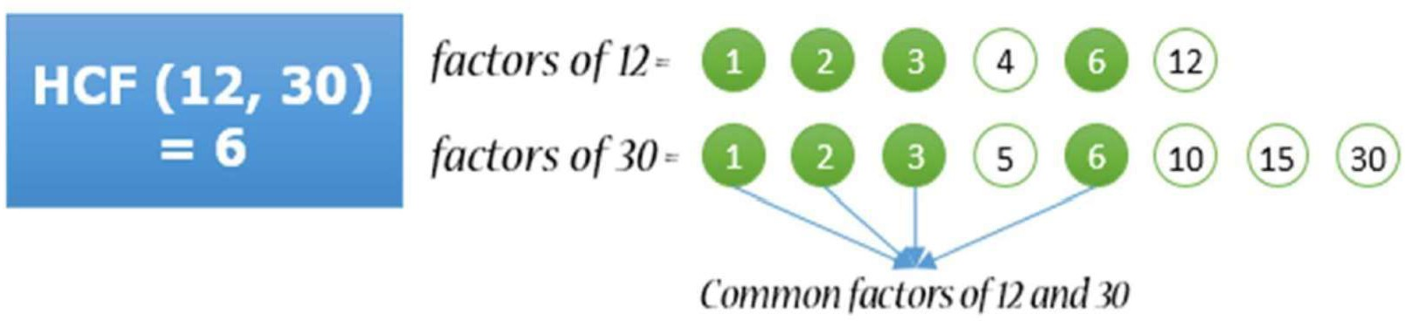

#include<stdio.h>

int hcf(int a,int b)

{

int c,d;

for(int i=a;i>=1;i--)

{

c=((a%i)==0);

d=((b%i)==0);

if(c&&d)

{

return i;

break;

}

}

}

int main()

{

int a,b;

printf("Enter two numbers ");

scanf("%d%d", &a,&b);

printf("The hcf of the numbers is %d",hcf(a,b));

}

1. Write a C program to find LCM of two numbers using functions. Example

Input

Output

Input first number: 12 Input second number: 30

LCM of 12 and 30: 60

Hint: LCM is a smallest positive integer that exactly divided by two or more numbers.

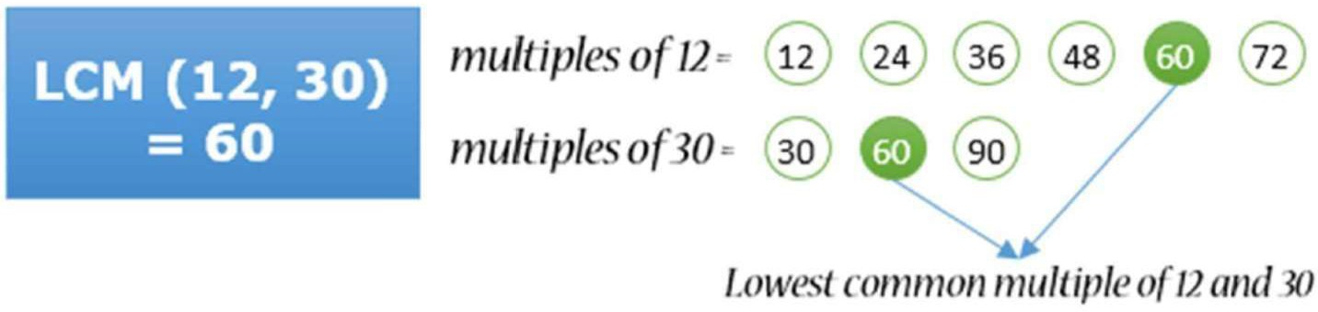

#include <stdio.h>

int lcm(int n1,int n2)

{

int i,gcd,lm;

for (i = 1; i <= n1 && i <= n2; ++i)

{

if (n1 % i == 0 && n2 % i == 0)

gcd = i;

}

lm = (n1 * n2) / gcd;

return lm;

}

int main()

{

int n1, n2,l;

printf("Enter two positive integers: ");

scanf("%d %d", &n1, &n2);

l=lcm(n1,n2);

printf("The LCM of two numbers %d and %d is %d.", n1, n2, l);

return 0;

}

1. Write a C program to find the two’s complement of a number using functions.

Hint: 2s complement of an N-bit number is defined as the complement with respect to 2N. It is the result of subtracting the number from 2N, which in binary is one followed by N zeroes. In simple words 2s complement is defined as sum of ones complement of a binary number and 1.

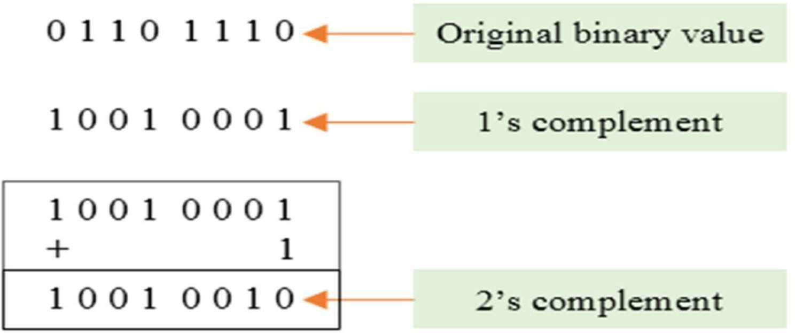

#include <stdio.h>

#include<math.h>

int cou(int a)

{

    int count=0;

    while (a!= 0) {

       count++;

       a >>= 1;

    }

    return count;

}

int main()

{

    int a,g,f;

    printf("enter number ");

    scanf("%d",&a);

    f=cou(a);

    g=pow(2,f)-a;

    printf("The 2's complement of %d is %d ",a,g);

    return 0;

}

**Method 2:** #include <stdio.h>

#include<math.h>

int main()

{

    int a,d,n,s=0,f=0,g=0,b;

    printf("enter number of bits ");

    scanf("%d",&b);

    printf("enter a binary number ");

    scanf("%d",&n);

    for(int i=0;i<b;i++)

    {

        d=n%10;

        n=(n-d)/10;

        d=!d;

        if(f==0 || g==1)

        {

            d=d+1;

        }

        if(d==2)

        {

                d=0;

                g=1;

        }

        else

            g=0;

        s=d*pow(10,f)+s;

        f++;

    }

    printf("%d",s);

    return 0;

}